TEAM-2
COURSE CODE: CSA1122
COURSE NAME: Object Oriented Analysis and Design

EXP:1: PASSPORT AUTOMATION SYSTEM
AIM: To draw the diagrams [usecase, activity, sequence, collaboration, class, statechart, collaboration, component, deployment, package] for the Passport Automation System.
SOFTWARE REQUIREMENTS SPECIFICATION: Umbrello
DIAGRAM:
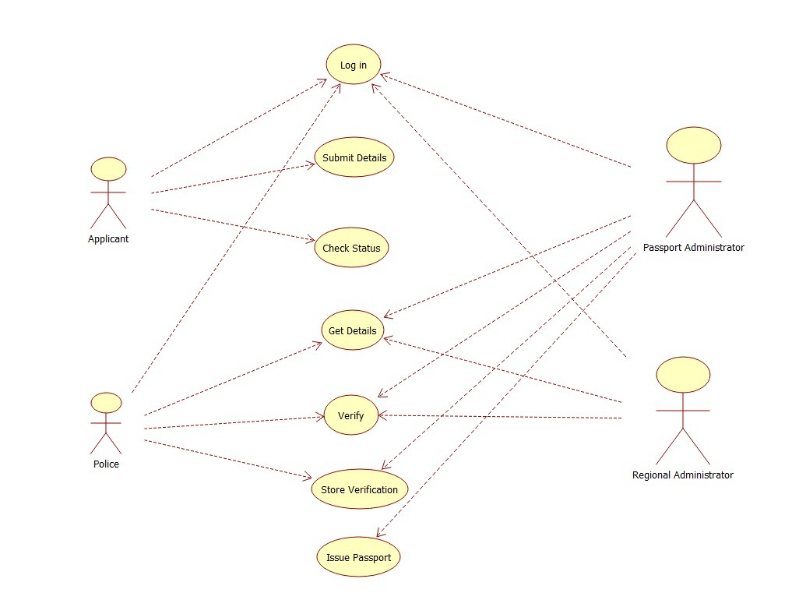
RESULT: Thus the diagrams [use case, activity, sequence, collaboration, class, collaboration, component, deployment, package ] for the Passport Automation system has been designed, executed and output is verified.

EXP:2: BOOK BANK REGISTRATION SYSTEM
AIM: To draw the diagrams [usecase, activity, sequence, collaboration, class, statechart, collaboration, component, deployment, package ] for the Book bank registration system.
SOFTWARE REQUIREMENTS SPECIFICATION: Umbrello
DIAGRAM:

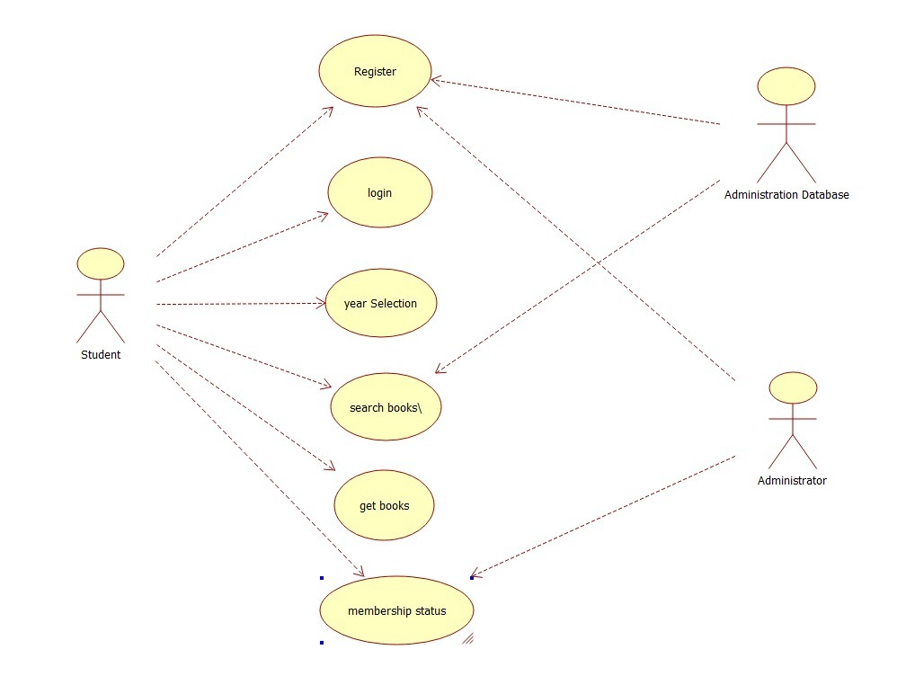
RESULT: Thus the diagrams [use case, activity, sequence, collaboration, class, collaboration, component, deployment, package ] for the Book bank registration system has been designed, executed and output is verified.

EXP:3: EXAM REGISTRATION SYSTEM
AIM: To draw the diagrams [use case, activity, sequence, collaboration, class, statechart, component, deployment, package] for the Exam registration system.
SOFTWARE REQUIREMENTS SPECIFICATION: Umbrello
DIAGRAM:

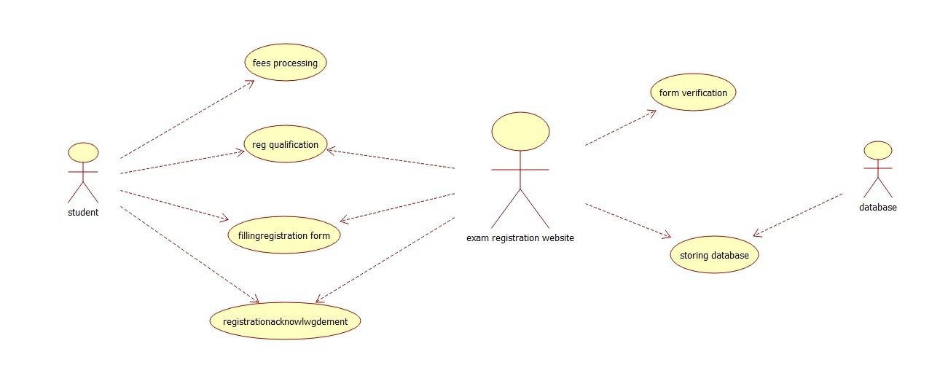
RESULT: Thus the diagrams [use case, activity, sequence, collaboration, class, statechart, component, deployment, package] for the Exam registration system.

EXP:4: STOCK MAINTAINANCE SYSTEM
AIM: To draw the diagrams [ usecase, activity, sequence, collaboration, class, collaboration, deployment, state chart , package] for the Stock maintainence system.
SOFTWARE REQUIREMENTS SPECIFICATION: Umbrello
DIAGRAM:

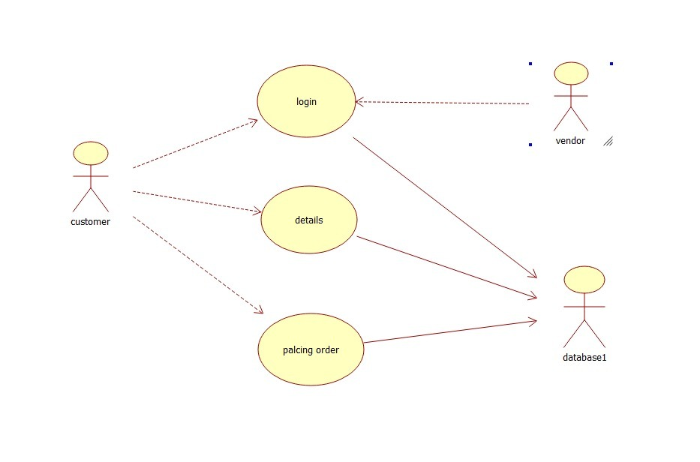
RESULT: Thus the diagrams [usecase, activity, sequence, collaboration, class, collaboration, deployment, compoenent, statechart, package] for the Stock maintainence system.

EXP:5: ONLINE COURSE RESERVATION SYSTEM

AIM: To draw the diagrams [usecase, activity, sequence, collaboration, class, statechart, component, deployment, package] for the Online course reservation system.
SOFTWARE REQUIREMENTS SPECIFICATION: Umbrello
DIAGRAM:
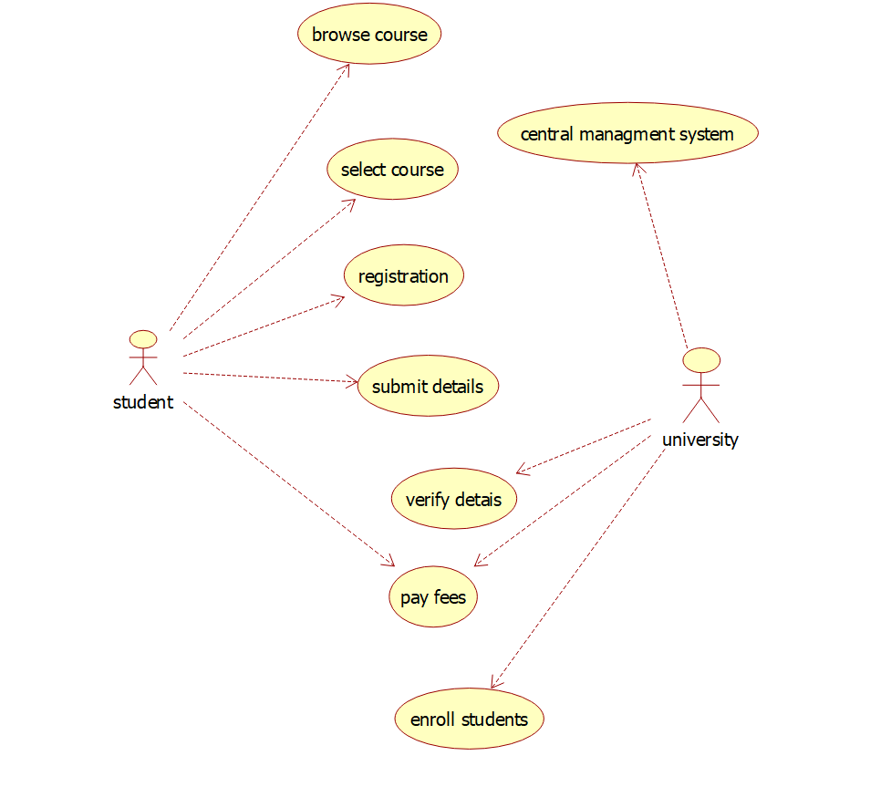
RESULT: Thus draw the diagrams [usecase, activity, sequence, collaboration, class,state chart, component, deployment , package] for the Online course reservation system has been designed executed and output is verified.

EXP:6: E-TICKETING

AIM: To draw the diagrams[use case, activity, sequence, collaboration, class, state chart, component, deployment, package] for the E-ticketing system.
SOFTWARE REQUIREMENTS SPECIFICATION: Umbrello

DIAGRAM:
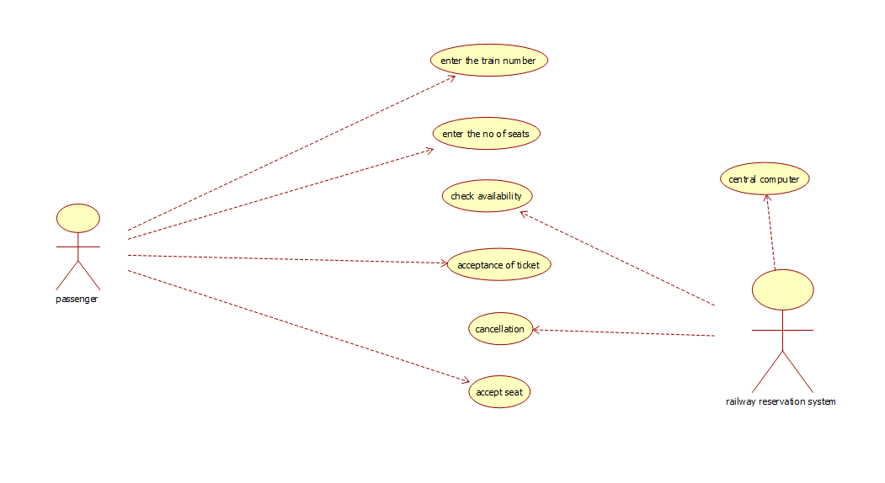

RESULT: Thus the diagrams[use case, activity, sequence, collaboration, class, statechart, component, deployment, package] for the E-ticketing system has been designed, executed and output is verified.

EXP:7: CREDIT CARD PROCESSING SYSTEM
AIM: To draw the diagrams [usecase, activity, sequence, collaboration, class, statechart, component, deployment, package ] for Credit Card Processing.
SOFTWARE REQUIREMENTS SPECIFICATION: Umbrello
DIAGRAM:
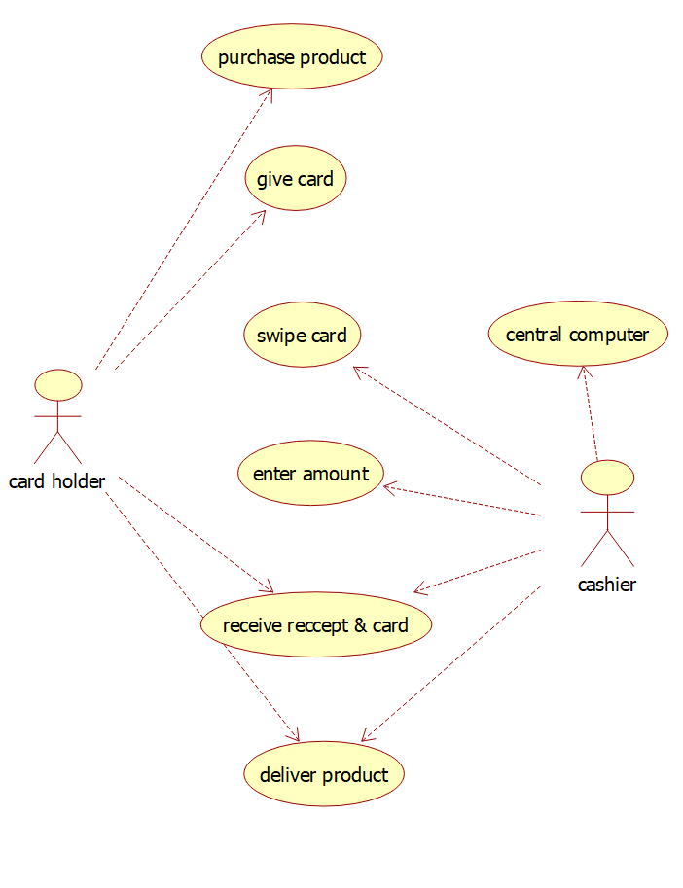
RESULT: Thus the diagrams[use case, activity, sequence, collaboration, class, state chart, component, deployment, package] for the credit card processing system has been designed, executed and output is verified.
EXP:8: SOFTWARE PERSONNEL MANAGEMENT SYSTEM
AIM: To draw the diagrams [ Usecase, Class, Activity, Sequence, Collaboration, State chart, Deployment, Component, package] for software personnel management system.
SOFTWARE REQUIREMENTS SPECIFICATION: Umbrello
DIAGRAM:
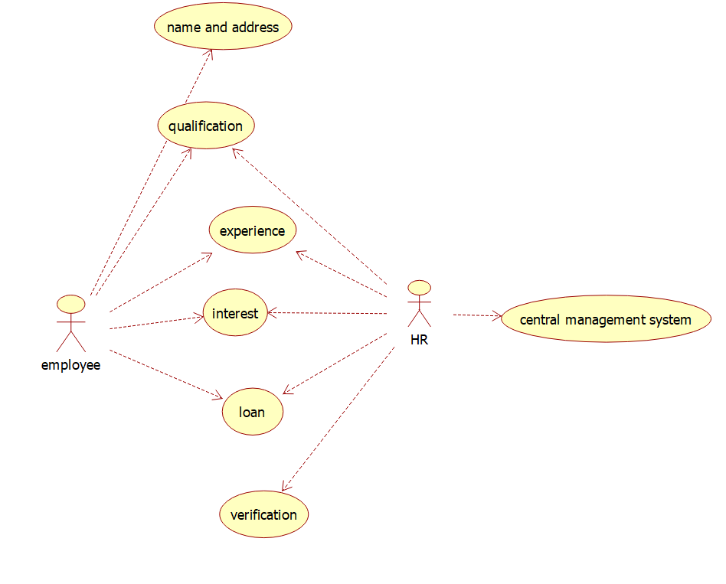
RESULT:
Thus the diagram [ usecase, class, activity, sequence, collaboration, state chart, component, deployment, package] for the Software Personnel Management System has been designed, executed and output is verified.

EXP:9: E-BOOK MANAGEMENT SYSTEM
AIM: To draw the diagrams [usecase, activity, sequence, collaboration, class, statechart, component, deployment, package ] for E-book management system.
SOFTWARE REQUIREMENTS SPECIFICATION: Umbrello

DIAGRAM:
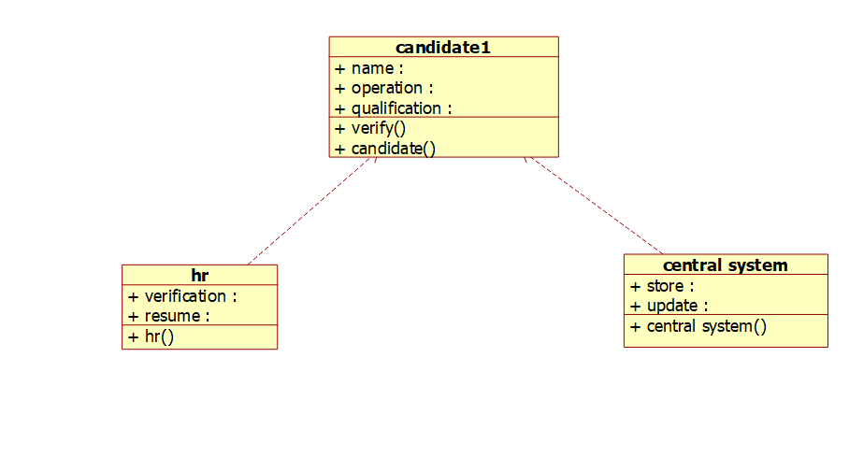
RESULT:
Thus the draw the diagrams [usecase, activity, sequence, collaboration, class, statechart, component, deployment, package ] for E-book management system.

EXP:10: RECRUITMENT SYSTEM
AIM: To draw the diagram[Usecase, Activity, Sequence, Collaboration, Class, StateChart, Component and Deployment, package] for recruitment system.
SOFTWARE REQUIREMENTS SPECIFICATION: Umbrello
DIAGRAM:
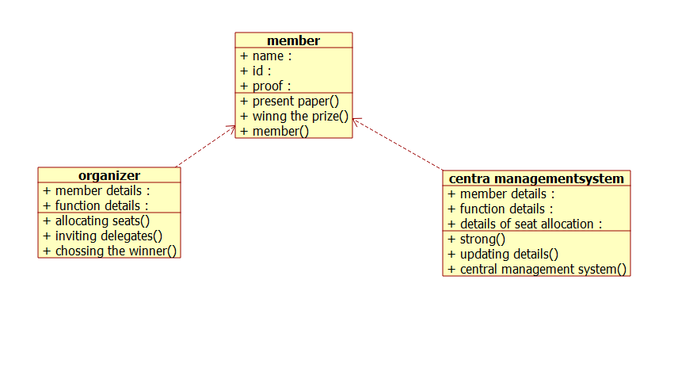
RESULT:
To draw the diagram [Use case, Activity, Sequence, Collaboration, Class, State Chart, Component and Deployment, package] for recruitment system has been designed and output is verified.

EXP:11: CONFERENCE MANAGEMENT SYSTEM
AIM: To draw the diagrams [use case, activity, sequence, collaboration, class, component, deployment, package] for Conference management system.
SOFTWARE REQUIREMENTS SPECIFICATION: Umbrello
DIAGRAM:
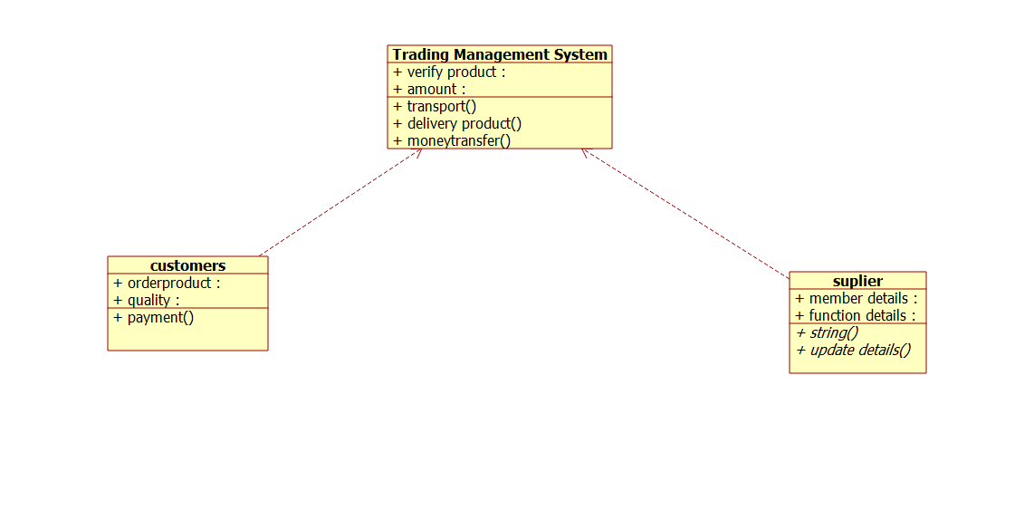
RESULT:
Thus draw the diagrams [use case, activity, sequence, collaboration, class, state chart, component, deployment, package] for Conference management system has been designed, executed and output is verified.

EXP:12: FOREIGN TRADING SYSTEM
AIM: To draw the diagrams [Use case, Activity, Sequence, Collaboration, Class, State chart, Component, Deployment, package] for foreign trading system.
SOFTWARE REQUIREMENTS SPECIFICATION: Umbrello
DIAGRAM:
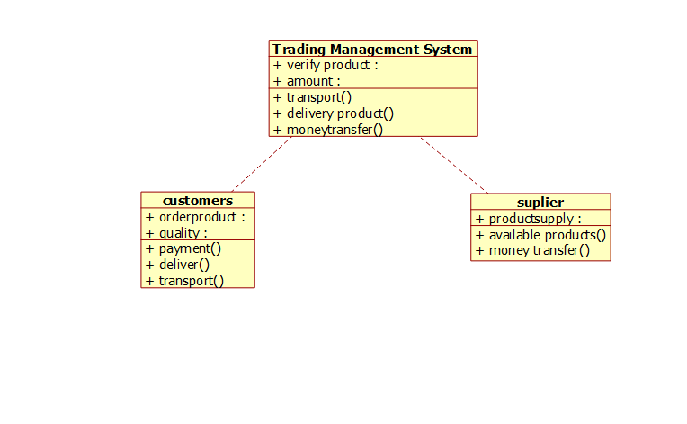
RESULT:
Thus thethe diagrams [Usecase, Activity, Sequence, Collaboration, Class, Statechart, Component, Deployment, package ] for foreign trading system has been designed, executed and output is verified.

EXP:13: BPO MANAGEMENT SYSTEM
AIM: To draw the diagrams [Use case, Activity, Sequence, Collaboration, Class, State chart, Component, Deployment, package] for BPO managment system.
SOFTWARE REQUIREMENTS SPECIFICATION: Umbrello
DIAGRAM:
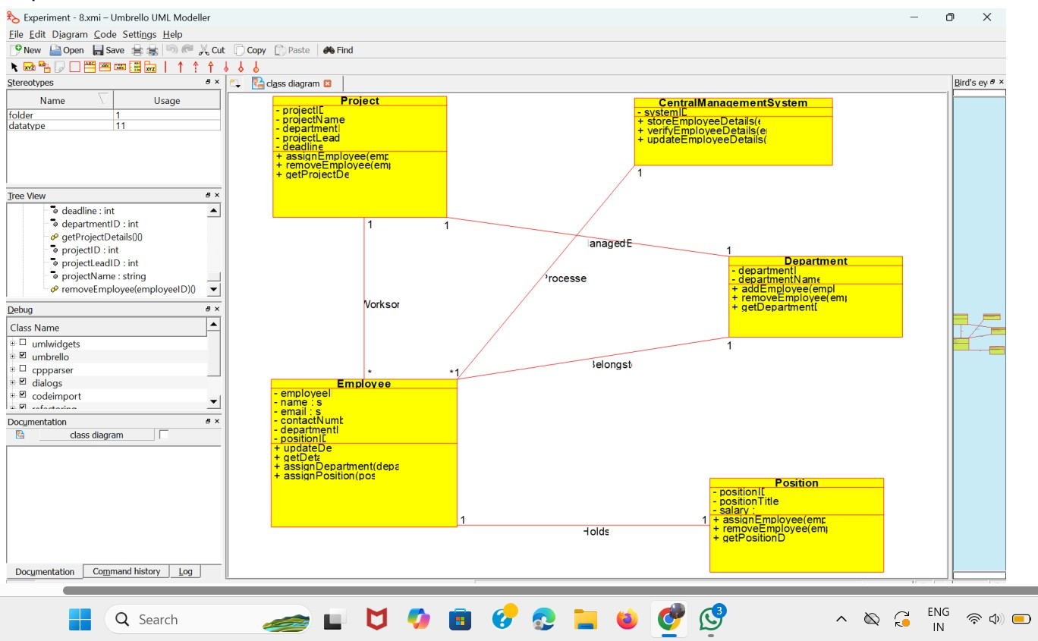
RESULT:
Thus thethe diagrams [Usecase, Activity, Sequence, Collaboration, Class, Statechart, Component, Deployment, package ] for BPO managment system has been designed, executed and output is verified.

EX.NO 14: E-COMMERCE REGISTRATION SYSTEM
AIM: To draw the Sequence diagram for the e-commerce registration system

SOFTWARE REQUIREMENTS: Umbrello

Output:

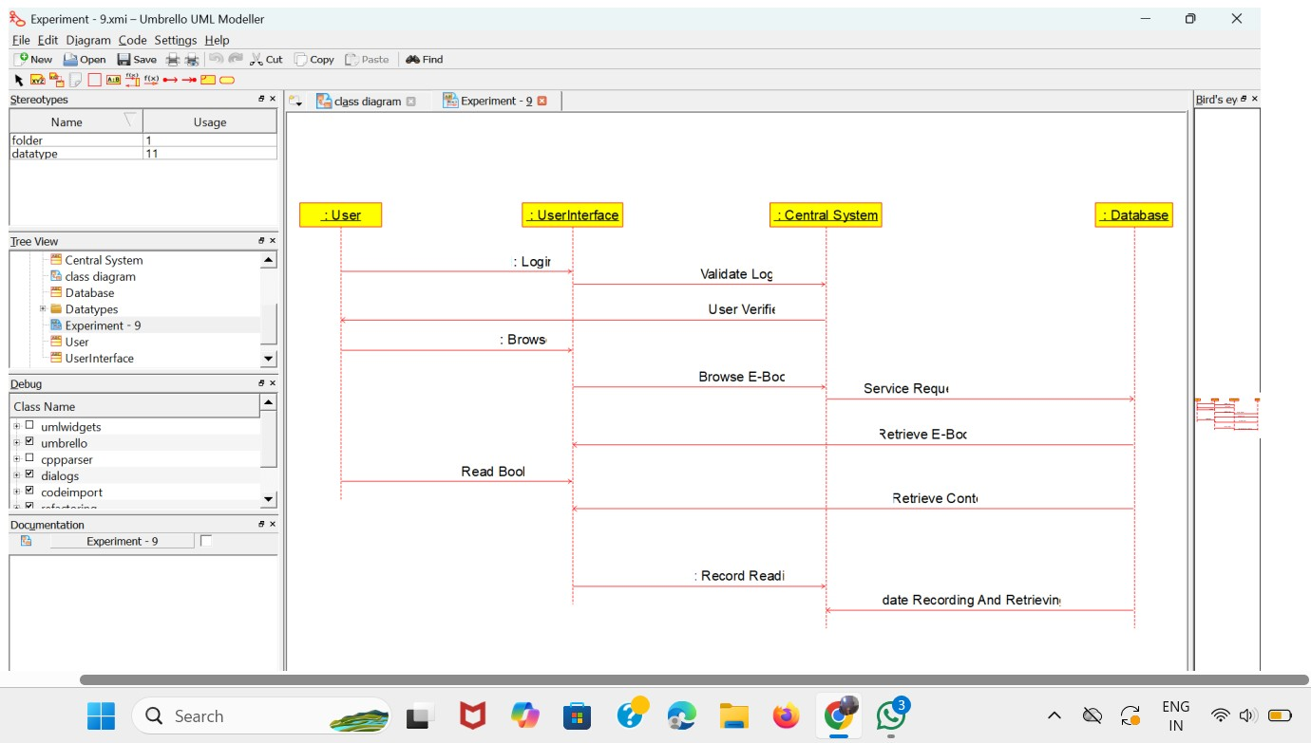
RESULT: The Sequence diagram for the e-commerce registration system has been designed, executed and output is verified

EX.NO: 15: BLOOD BANK REGISTRATION SYSTEM
AIM: To draw the Sequence diagram for the bank registration system.
SOFTWARE REQUIREMENTS: Umbrello

OUTPUT:

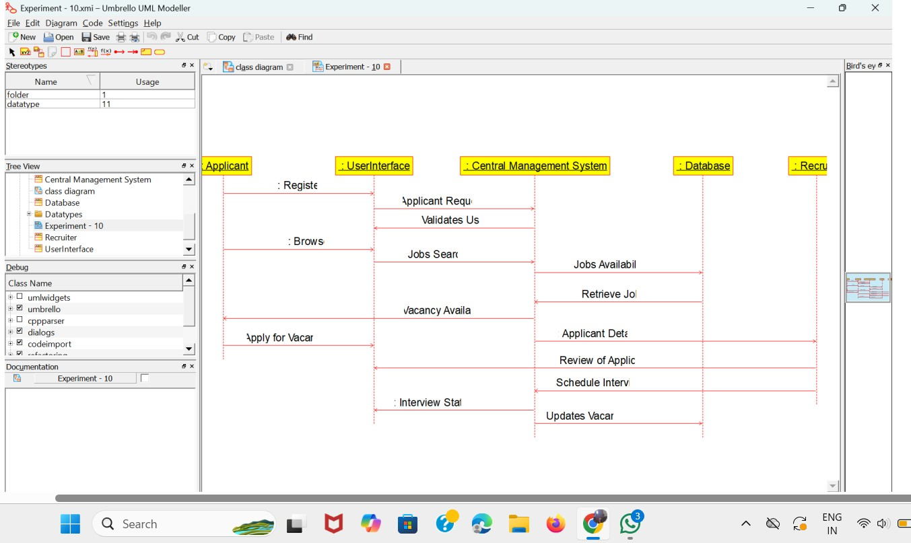
RESULT: The Sequence diagram for the blood bank registration system system has been designed, executed and output is verified

EX.NO: 16: Online Internship Registration System

AIM: Develop a system using UML for Online Internship Registration System.
SOFTWARE REQUIREMENTS: Umbrello software

CLASS DIAGRAM:

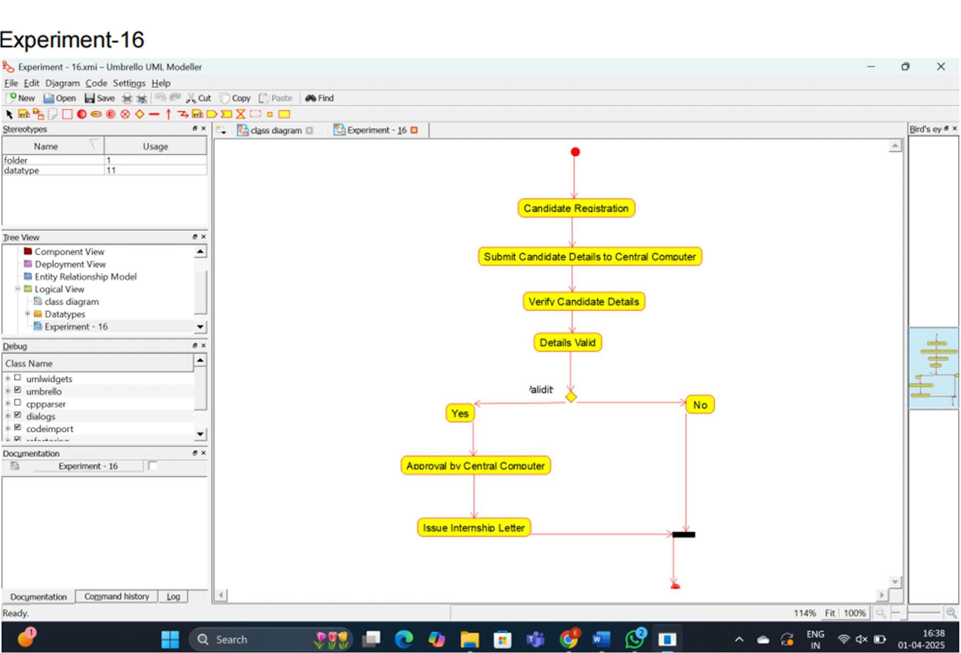
RESULT:
Thus, to design UML diagram for Online Internship Registration System. using umrbello software.

EX.NO: 17: Vehicle Registration Number Registering System

AIM: Develop a system using UML for Vehicle Registration Number Registering System.
SOFTWARE REQUIREMENTS: Umbrello software

CLASS DIAGRAM:

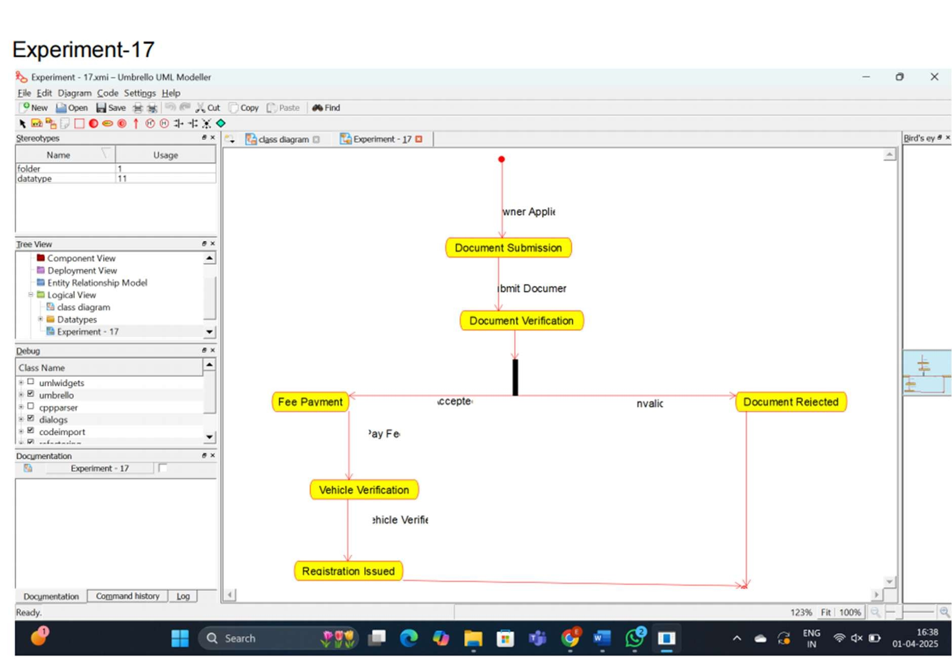

RESULT: Thus, to design UML diagram forVehicle Registration Number Registering System using umrbello software.

EX.NO: 18: Food Order System

AIM: Develop a system using UML for Food Order System.
SOFTWARE REQUIREMENTS: Umbrello software

CLASS DIAGRAM:

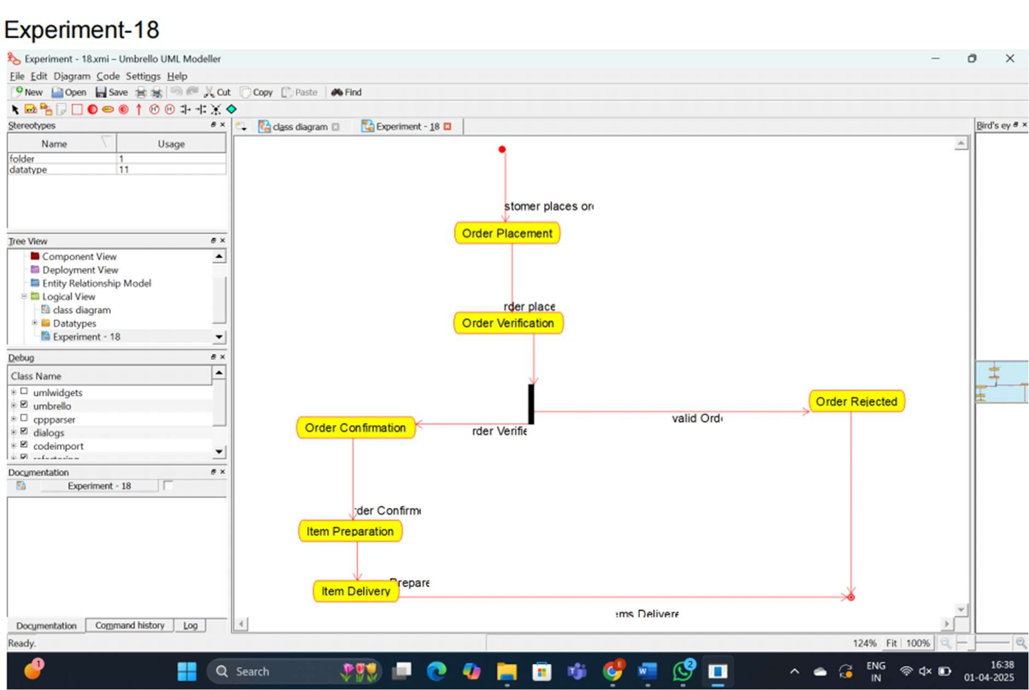
RESULT:
Thus, to design UML diagram for Food Order System. using umrbello software.

EX.NO: 18: Home Services System

AIM: Develop a system using UML for Home Services System.
SOFTWARE REQUIREMENTS: Umbrello software

CLASS DIAGRAM:

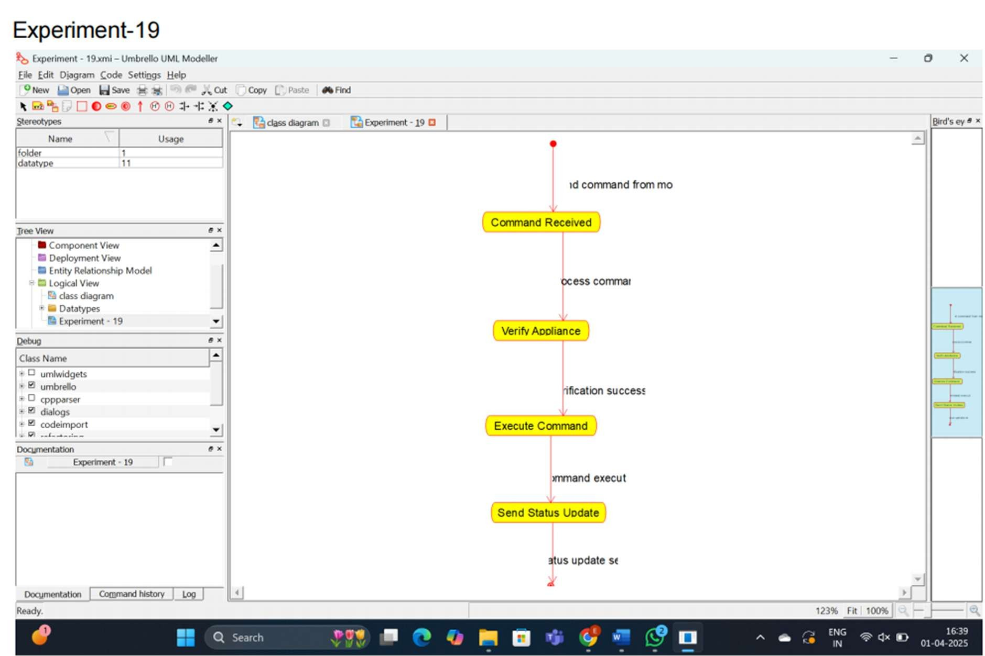
RESULT:
Thus, to design UML diagram for Home Services System. using umrbello software.

EX.NO: 20: Library Management System

AIM: Develop a system using UML for Library Management System.
SOFTWARE REQUIREMENTS: Umbrello software

CLASS DIAGRAM:

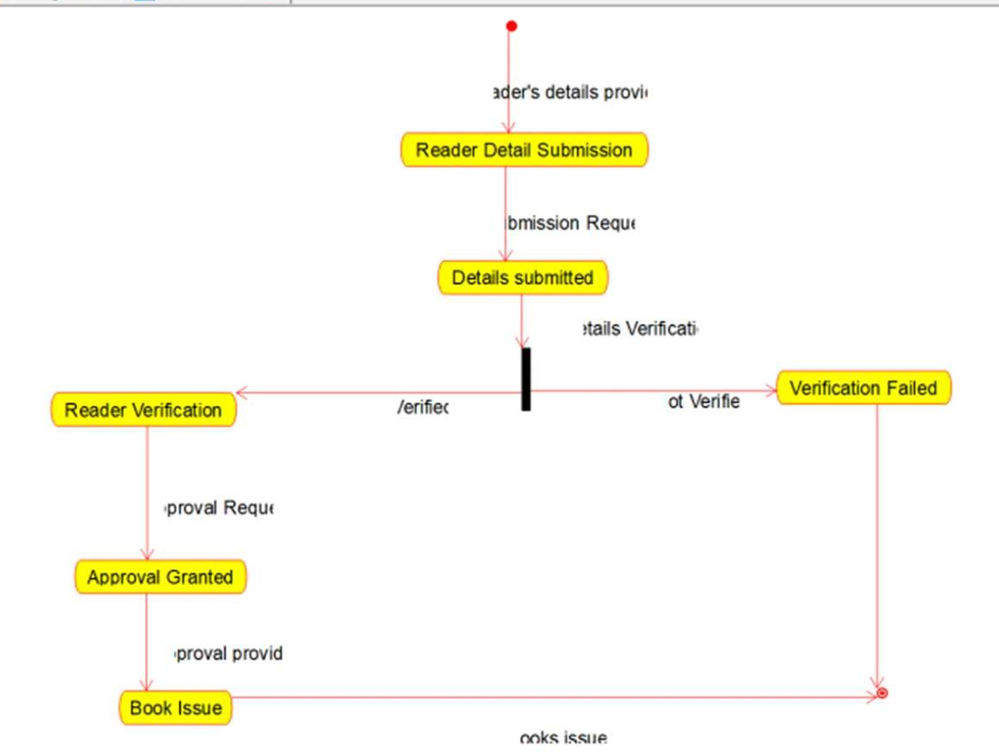
RESULT:
Thus, to design UML diagram for Library Management System. using umrbello software.

EX.NO: 21: Hospital Management System

AIM: TO draw the class diagram for Hospital Management System

Software Requirement: Umbrello

Class Diagram :

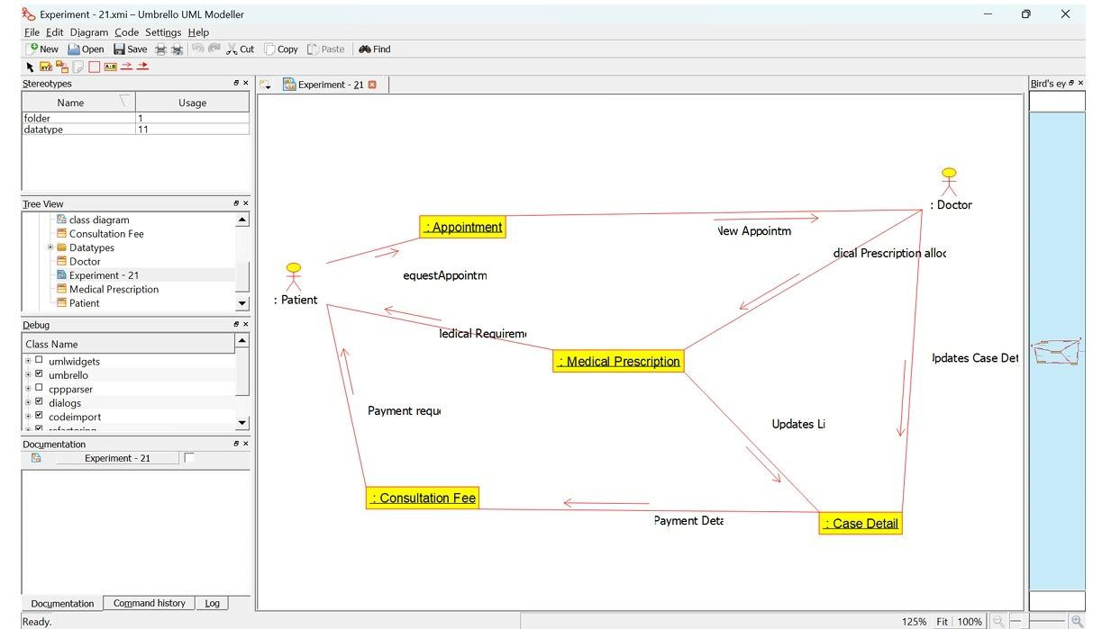

Result: Thus the diagram for Hospital Management System has been designed executed and output verified

EX.NO: 22: Onilne Insurance Processing System

AIM: TO draw the state diagram for Online Insurance Processing System.

Software Requirement: Umbrello

State diagram:

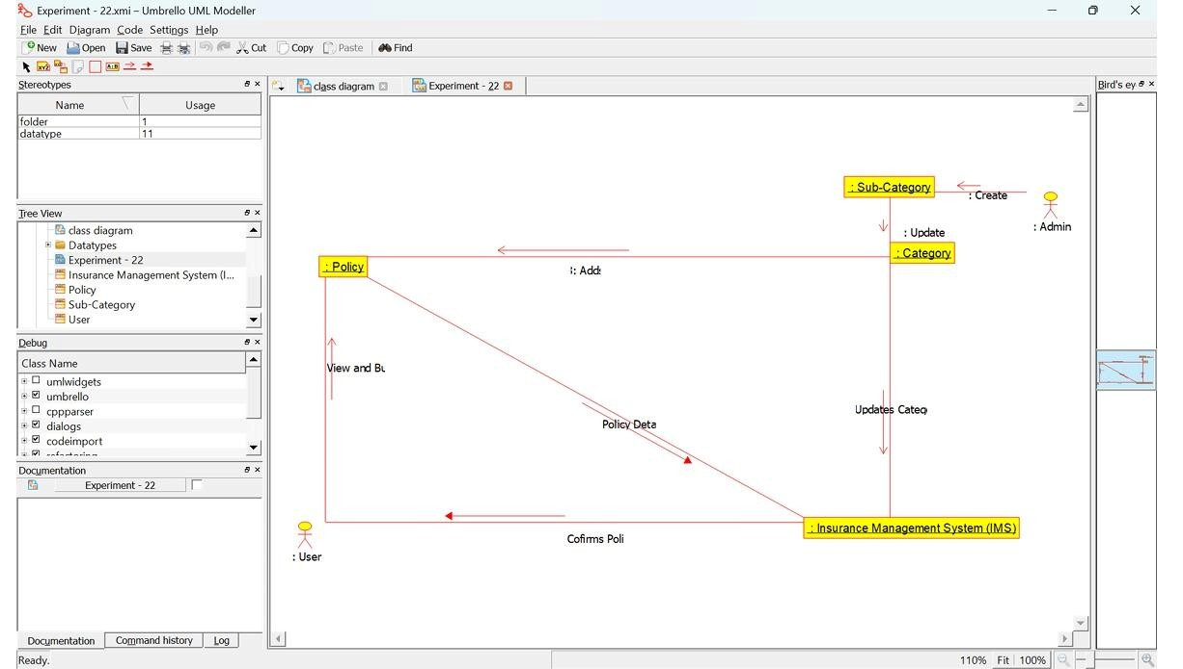

Result: Thus, the diagram for Online Insurance Processing System. has been designed executed and output verified

EX.NO: 23: Online Shopping System

AIM: TO draw the state diagram for the Online Shopping System.

Software Requirement: Umbrello

State diagram:

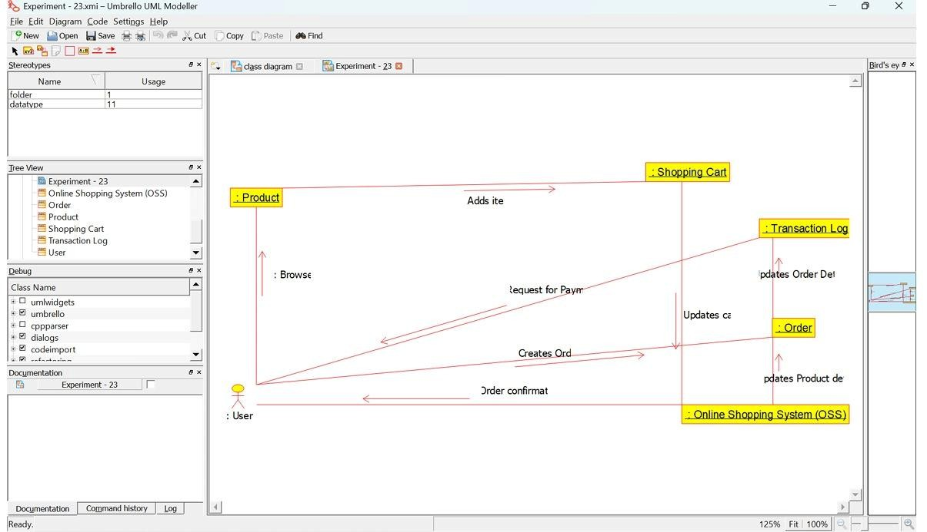

Result: Thus, the diagram for Online Shopping System. has been designed executed and output verified

EX.NO: 24: Online Stock Market System

AIM: TO draw the state diagram for the Online Stock Market System.

Software Requirement: Umbrello

State diagram:

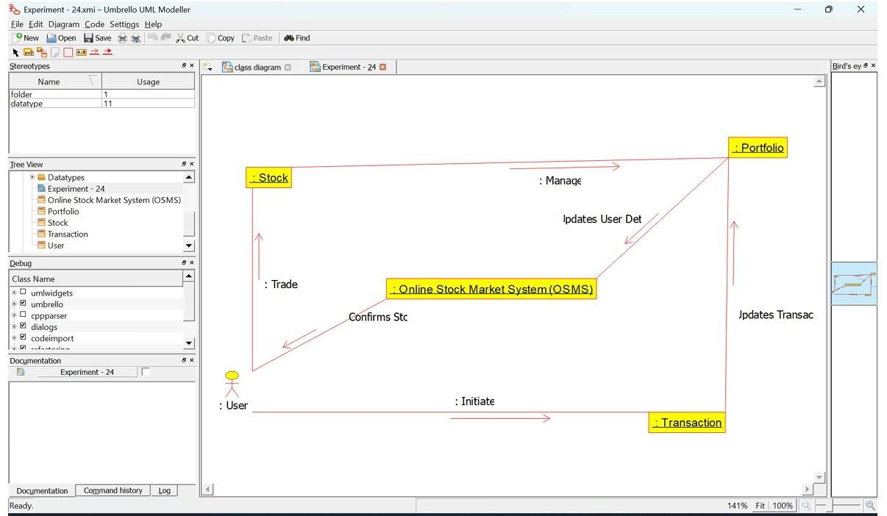

Result: Thus the diagram for Online Stock Market System has been designed executed and output verified

EX.NO: 25: Online Voting System

AIM: TO draw the state diagram for the Online Voting System

Software Requirement: Umbrello

State diagram:

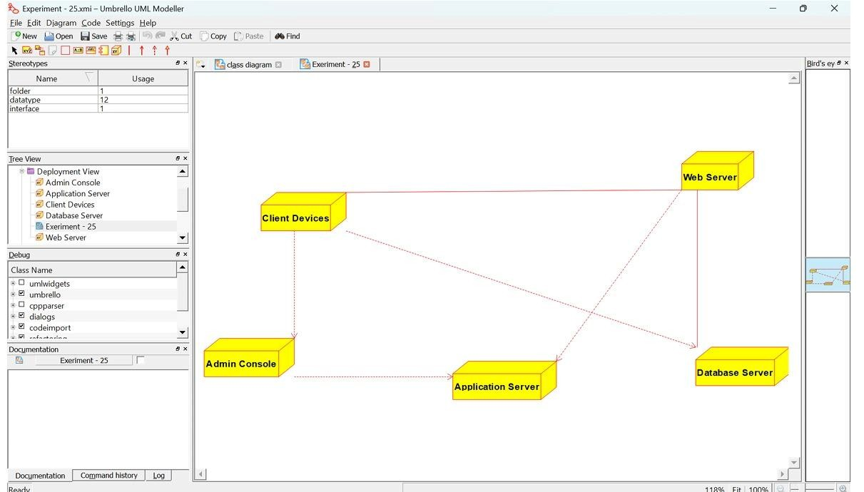
Result: Thus, the diagram for Online Voting System has been designed executed and output verified
EX.NO: 26: Jewellery shop Management System

AIM: To draw the deployment diagram for the Jewellery Management System
SOFTWARE REQUIREMENTS: Umbrello UML modeller

DEPLOYMENT DIAGRAM

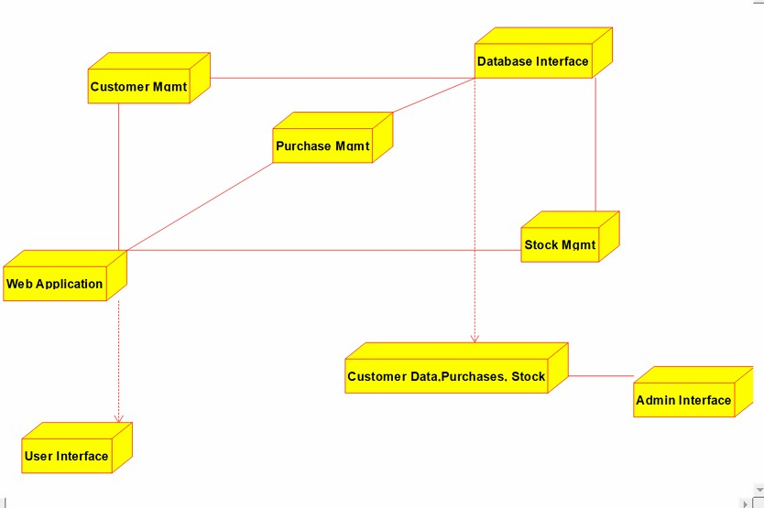

RESULT:
Thus the deployment diagram for the Passport Automation system has been designed, executed and output is verified.

EX.NO: 27: Supermarket Management System

AIM: To draw the deployment diagram for the Supermarket Management System
SOFTWARE REQUIREMENTS: Umbrello UML modeller

DEPLOYMENT DIAGRAM

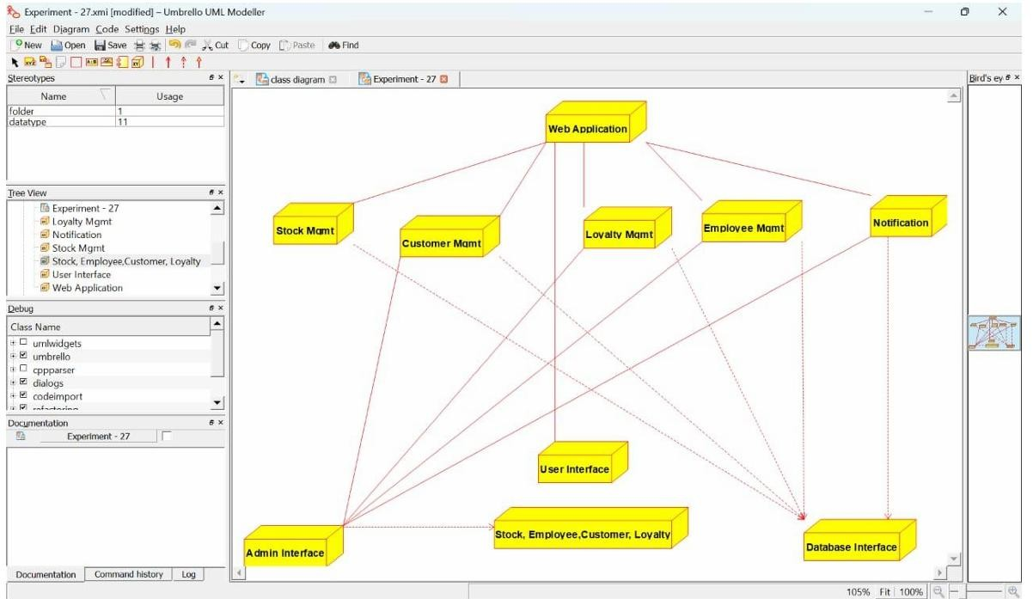

RESULT:
Thus the deployment diagram for the Supermarket Management System has been designed, executed and output is verified.

Ex.No: 28: Airplane Reservation System
AIM: To draw the deployment diagram for the Airplane Reservation System
SOFTWARE REQUIREMENTS: Umbrello

DEPLOYMENT DIAGRAM

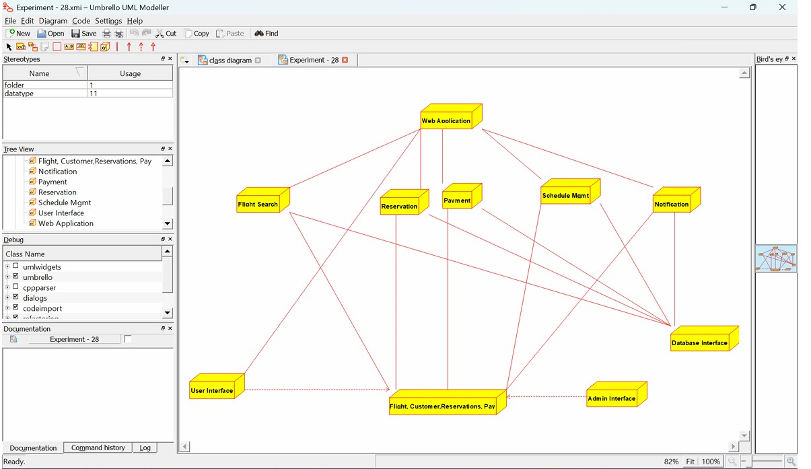

RESULT:
Thus the deployment diagram for the Airplane reservation system has been designed, executed and output is verified.

Ex.No: 29: Bus Ticket Reservation System
AIM: To draw the class diagram for the Bus ticket System
SOFTWARE REQUIREMENTS: Umbrello
CLASS DIAGRAM:

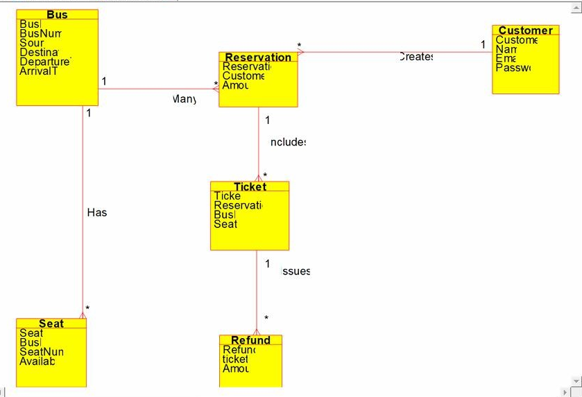

RESULT:
Thus the class diagram for the Bus ticket Reservation system has been designed, executed and output is verified.

Ex.No: 30: Train Ticket Reservation System
AIM: To draw the class diagram for the Train Ticket Reservation System
SOFTWARE REQUIREMENTS: Umbrello
CLASS DIAGRAM:

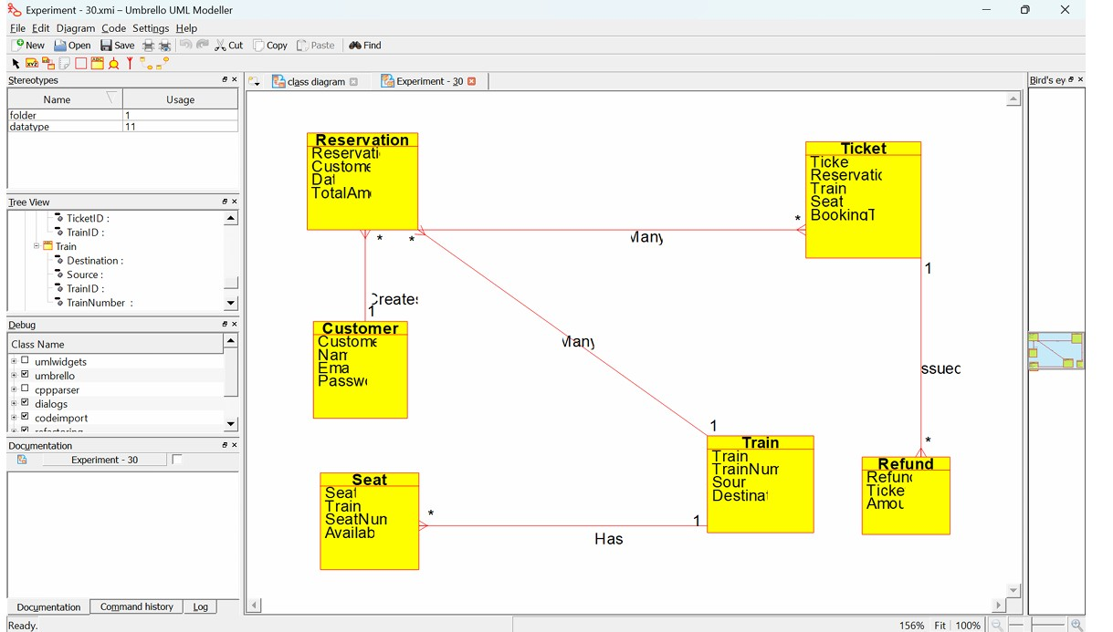

RESULT:
Thus the class diagram for the Train Ticket Reservation System has been designed, executed and output is verified.

Ex.No: 31: Agriculture Loan Management System

AIM: To draw the class diagram for the Agriculture Loan Management System
SOFTWARE REQUIREMENTS: Umbrello
CLASS DIAGRAM
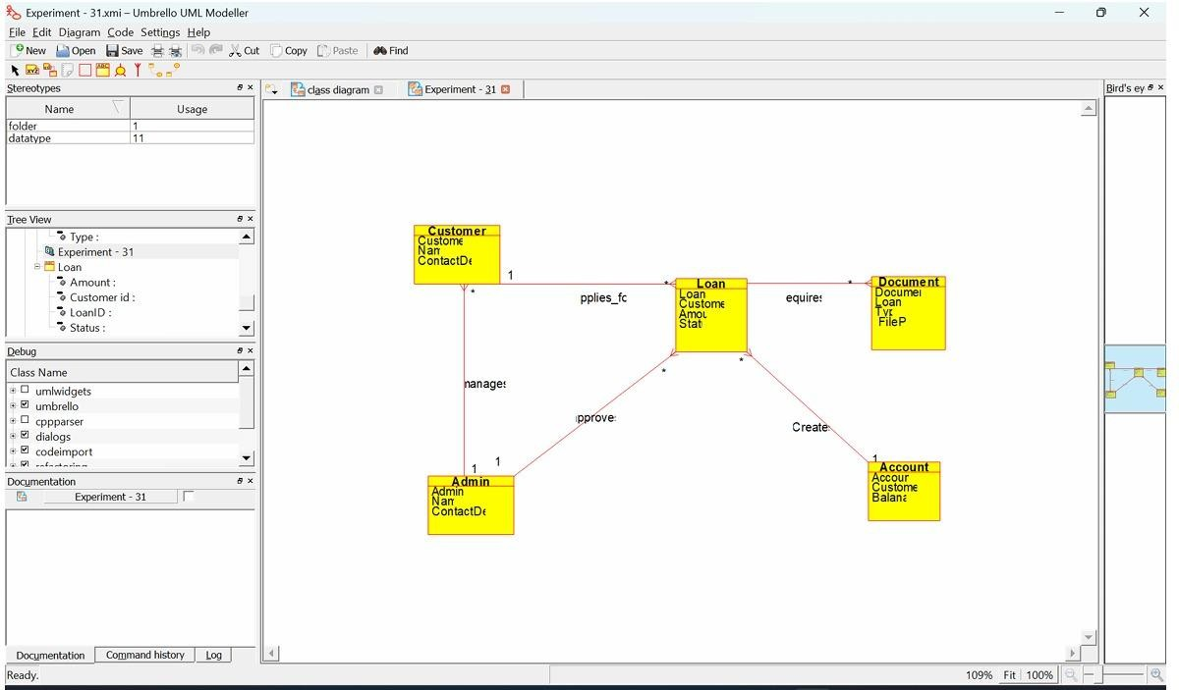
RESULT:
Thus the class diagram for the Agriculture Loan Management System has been designed, executed and output is verified.

Ex.No: 32:Jewel Loan Management System.

AIM: To draw the class diagram for the Jewel Loan Management System.
SOFTWARE REQUIREMENTS: Umbrello
CLASS DIAGRAM
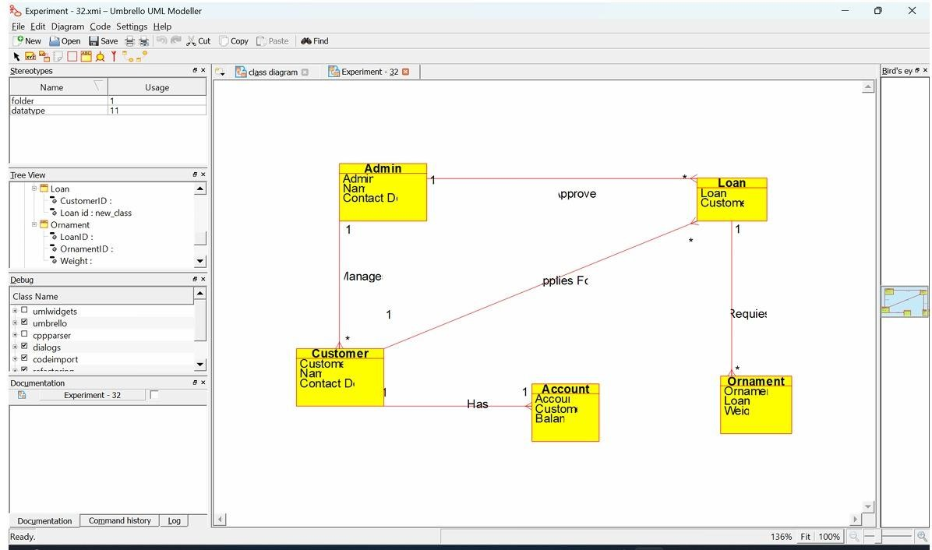
RESULT:
Thus the class diagram for the Jewel Loan Management System has been designed, executed and output is verified.

Ex.No: 33: Personal Loan Management System
AIM:
To draw the component diagram for the Personal Loan Management System
SOFTWARE REQUIREMENTS: Umbrello
COMPONENT DIAGRAM
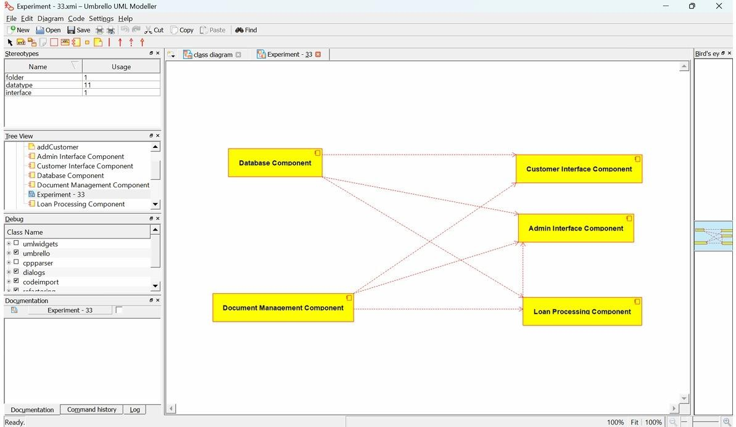
RESULT:
Thus the component diagram for the Personal Loan Management System has been designed, executed and output is verified.

Ex.No: 34: Home Loan Management System

AIM: To draw the component diagram for the Home Loan Management System SOFTWARE REQUIREMENTS: Umbrello
COMPONENT DIAGRAM

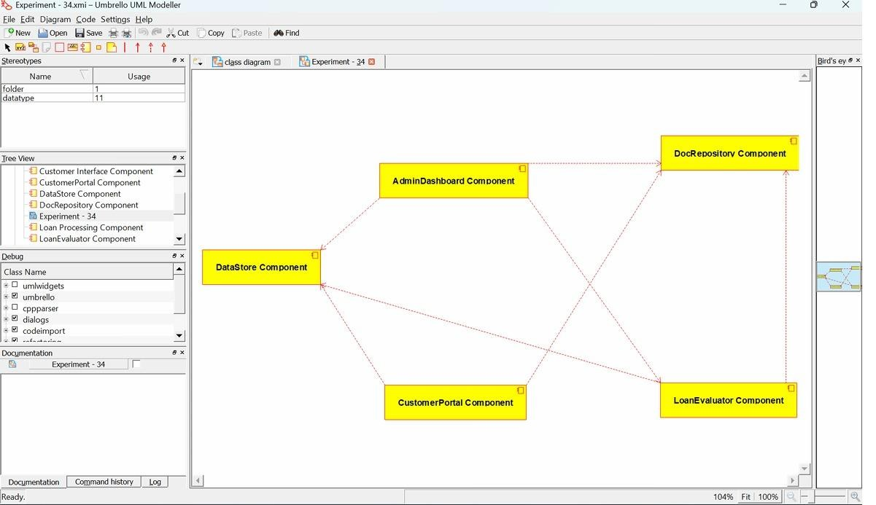
RESULT:
Thus the component diagram for the Home Loan Management System has been designed, executed and output is verified.

Ex.No: 35: Land Registration System
AIM: To draw the component diagram for the Land Registration System.
SOFTWARE REQUIREMENTS: Umbrello
COMPONENT DIAGRAM
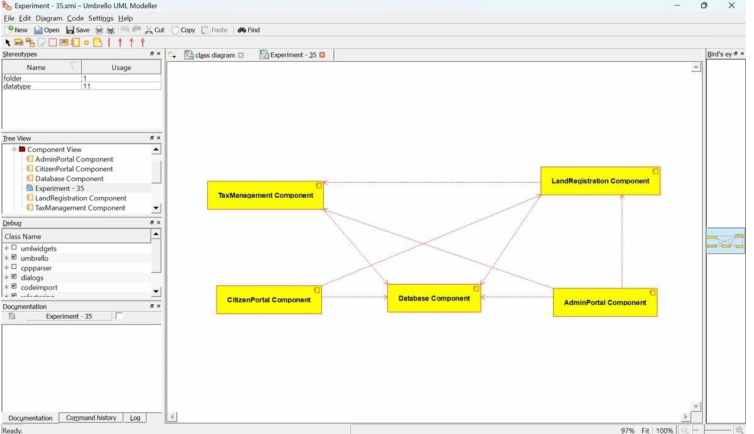
RESULT:
Thus the component diagram for the Land Registration System has been designed, executed and output is verified.

Ex.No: 36: Car/Bike Vehicle Booking System

Aim: The aim of this project is to develop a Car/Bike Vehicle Booking System using UML that allows customers to rent different types of automobiles efficiently.
Software used: Umbrello
Component diagram:

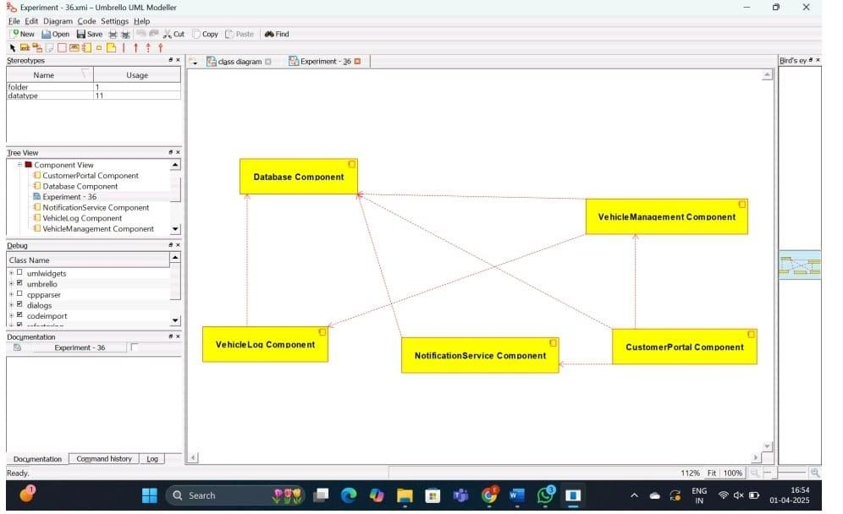

Result: Thus, the project of implementing the Car/Bike Vehicle Booking System is created and the implementation of the program in Java is successfully done.

Ex.No: 37: Doctor Appointment System

Aim: To design a UML diagram for Doctor Appointment System using umbrello software and implement the program in java.
Software used: Umbrello
Class Diagram:

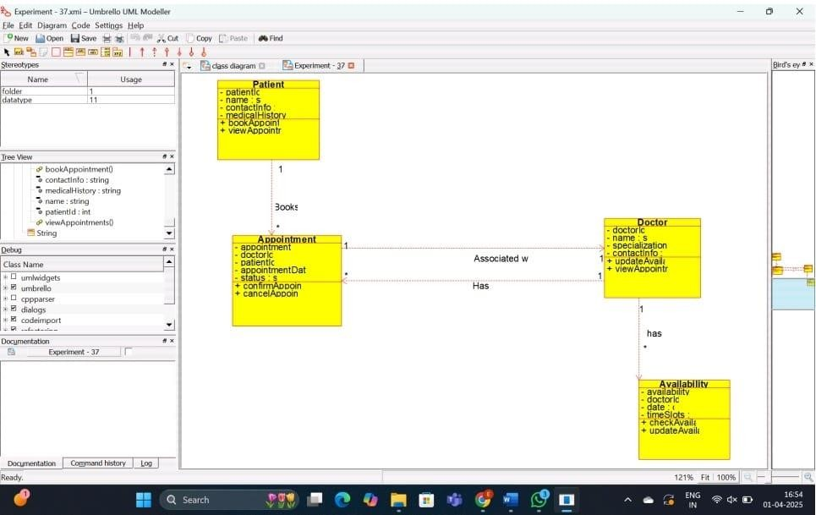

Result: Thus the project of implementing the Doctor Appointment System is created and the implementation of program in java is successfully done.

Ex.No: 38: Salon/Beauty Parlour Reservation System

Aim: To design a UML diagram for Salon/Beauty Parlour Reservation System using umbrello software and implement the program in java.
Software used: Umbrello
Daigram:

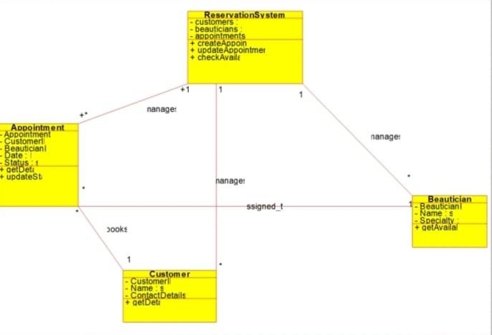

Result: Thus the project of implementing the Salon/Beauty Parlour Reservation System is created and the implementation of program in java is successfully done.

Ex.No: 39: Gardener Booking System

Aim: To design a UML diagram for Gardener Booking System using umbrello software and implement the program in java.
Software used: Umbrello
Diagram:

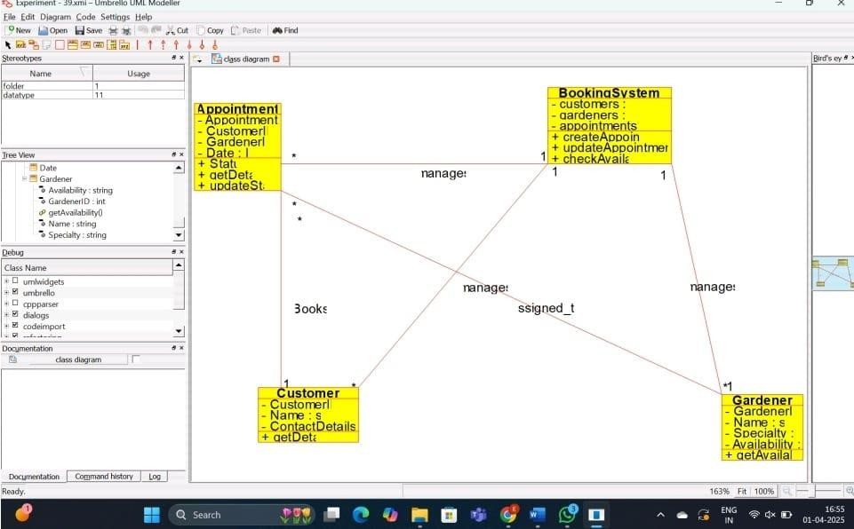

Result: Thus the project of implementing the Gardener Booking System is created and the implementation of program in java is successfully done.

Ex.No: 40: HOME Tax Collection System

Aim: To design a UML diagram for HOME Tax Collection System using umbrello software and implement the program in java.
Software used: Umbrello
Diagram:

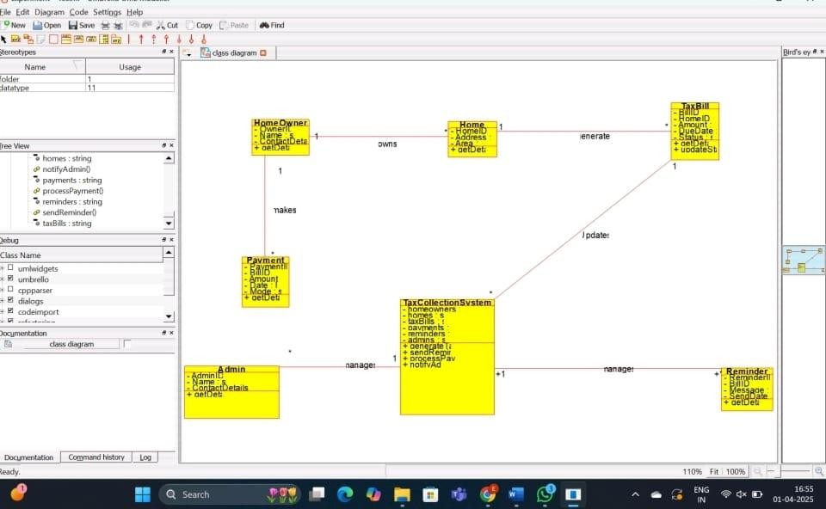

Result: Thus the project of implementing the HOME Tax Collection System is created and the implementation of program in java is successfully done

